**Git Manual**

**git –version**

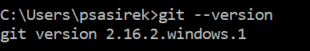

**Make a directory**

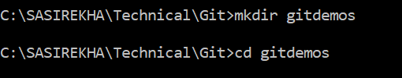

**ls -la**

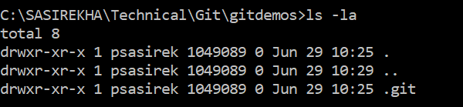

**git init**- creates a .git directory which contains all of the repositories and its files.



Now I can add a file to repository **Readme.txt** and add the text **–“Hello Git “and** running **git status –** This tells me that **Readme.txt** is untracked file. Means git is not having this file in its repository yet.

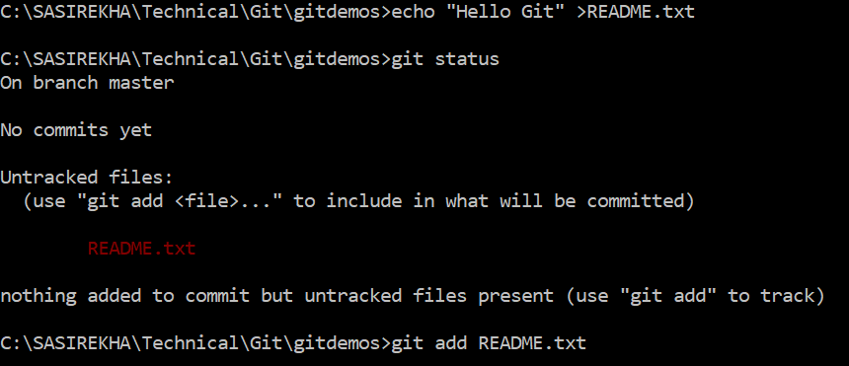

To add it in to git repository I can type **git add README.txt** and **git stauts** again.

Git now notices that this file is a new file and is stagged to be added to the repository which I can do by running **git commit.**

Git commit brings up the default text editor , and Type Added Readme.txt .

Git log – to get the details